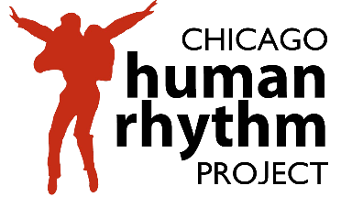

Rhythm World 32 July 8 – 24, 2022 Tap Scholar Application

Welcome to Chicago Human Rhythm Project’s Tap Scholar Program. This year, we will award up to $10,000 in scholarships through video auditions. Some awards will be given through auditions in Canada, Japan, Brazil and Germany. Since the Tap Scholar program began in 1995, CHRP has given more than $350,000 in tuition waivers to talented, deserving young dancers to support their dreams and aspirations. Past multi-year, scholarship winners have included Ian Berg, Star Dixon, Nico Rubio, Jumaane Taylor, and many other leading lights in the tap community.

Scholarships are awarded to students based on financial need, talent, skill, attitude, and artistic merit. The Tap Scholar program brings together students from different socio-economic, geographic, ethnic, and experiential backgrounds in an intense, immersion program that facilitates mutual appreciation and respect. Tap Scholar Award winners will have an opportunity to study with many of the greatest living masters of American tap and percussive dance, meet peers from around the world and give back to the community by providing critical support to the faculty and festival staff. The Tap Scholar Program runs concurrently with RHYTHM WORLD, July 8 - 24, 2022 and includes master classes, courses, Choreographic Residency, American Tap Conservatory and concert admission.

CHRP education staff will work with Tap Scholar Award winners to design an individual curriculum based on skill level, program content and faculty preferences. Final curriculum decisions are made by the Artistic Director, Jumaane Taylor. Students may register after a student/teacher conference.

Tap Scholar Policies
These rules are intended to ensure that you receive the most from your experience and that a respectful and friendly environment is maintained for the entire program.

Tap Scholar Award winners are required to use the full value of the award. If a student cannot use the entire award, it will be given to another student.
- Tickets to performances must be reserved at time of registration.
- Awardees must be punctual and attend ALL registered classes, meetings, and support activities.
- Awardees must pay the $35 festival registration fee.
- Award decisions are final and Awards are non-transferable.
- Awardees must be 12 - 18 years old at the time of the festival (July 20 – 26, 2020).
- When computing tuition total, scholarship students must mark the full price, not discounted or early bird tuition prices.
- Awardees must register for the summer festival by June 8, 2022. Forms must be received by this date. If we do not receive your festival registration postmarked by this date, the scholarship will be offered to another student. If you accept a scholarship and fail to notify CHRP of a change in your plans, you will be ineligible to receive future Tap Scholar Awards.
TAP SCHOLAR APPLICATION

1) PERSONAL INFORMATION: (Please print clearly.)

Student Name:
Date of birth: Age:
Preferred Phone: Alternate:
Email Address:
Parent or Guardian’s Name:
Parent Phone: Alternate:
Parent E-mail:
Applicants will be notified by email of scholarship award.

2) STUDENT PERSONAL STATEMENT: Student should complete this. Describe how you will benefit from this scholarship and how it will further your tap education. You could include your passion for tap, career goals, and/or your dreams, etc. (300 word limit)

3) PARENT/GUARDIAN STATEMENT OF FINANCIAL NEED: Parent or guardian should complete this section. Include information about your family’s need for tuition assistance including total number of dependent family members and IRS, FY21 (FY20 if not available) adjusted gross income.

4) DANCE TRAINING:
Current tap and other dance teacher(s) name, studio(s) name, years studied and URLs:

5) DESCRIPTION OF OTHER PARTICIPATION IN TAP DANCE: Please include information about tap experience outside of class including performance experience, recitals, competitions, workshops, camps, etc. (200 word limit)

6) Each applicant must also submit a link to an audition video.

Video auditions must:

i. Have been shot no more than six months prior to submission
ii. Have clear audio in which the feet can be clearly heard and good video quality

Digital Auditions must include:

i. Brief verbal self‐introduction, 1 minute maximum
ii. Technique sampler, 5 minute max: Include drills/exercises of diﬀering rhythms/styles.
iii. Performance sampler, 8 minutes maximum: Provide 2‐3 combinations, improvisations, and/or repertory excerpts, shot in the studio, that demonstrate a range of dynamics, levels, tempos, and styles; and identify choreographers for works shown. (e.g. Swing, Latin, Funk)

7) Return this application to:

Chicago Human Rhythm Project
Tap Scholar Program
410 S. Michigan Ave, Studio 464
Chicago, IL 60605

Or by email to:

registration@chicagotap.org

Application must be completed and returned before June 8, 2022.

LATE APPLICATIONS WILL NOT BE CONSIDERED.
Please return this form with the tap scholar application (before the scholarship audition).

Parent(s) Name: _____________________________________________________________________

Number of dependent family members
(including parents and children) living at home: ____________________________________________

Estimated total family, adjusted gross income FY 2021: ______________________________________

Signature

I, ______________________________, attest that the above financial information that I have provided is true and accurate.

______________________________________________________
Parent Signature Date

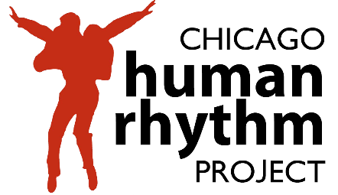
Tap Scholar Program
Application Form

